**Readme**

1. **Function Diagram**

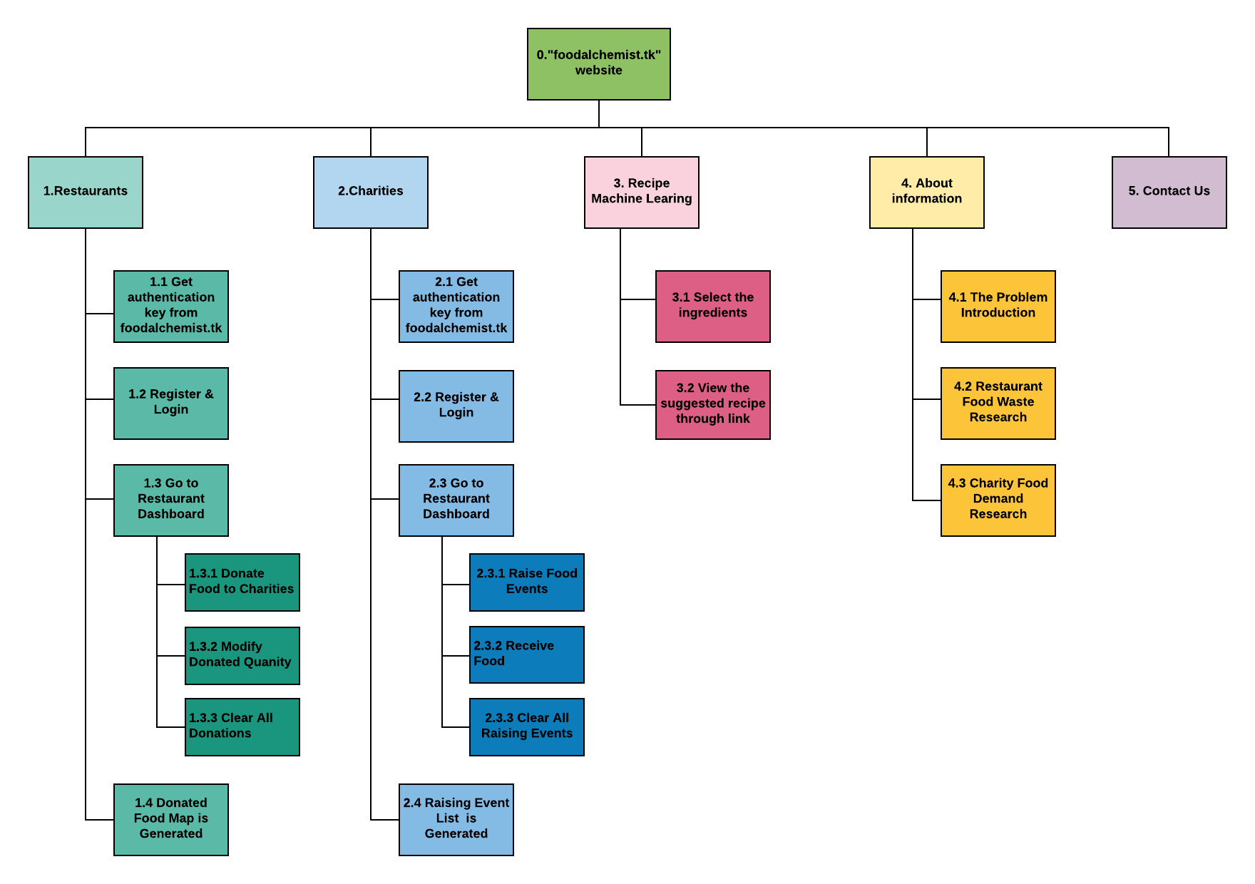

**2. Description of functions**

Restaurant:

* Get an Authentication key from “foodalchemist”.
* Register an account based on the given Authentication key, and create a unique username with a password.
* Login with their username and password to access the donation dashboard.
* Submit a “Donate food” form with valid food name, food category and quantity.
* While donating their food, they can modify the food quantity and even can clear their own donations.
* On the donation dashboard, there is a bar graph displaying all the donation details for this restaurant.
* Food donation map will be generated based on all restaurant donation activities, and the clickable markers can display eligible restaurants’ address, food name, food category and quantity.

Charity:

* Get an Authentication key from “foodalchemist”.
* Register an account based on the given Authentication key, and create a unique username with a password.
* Login with their username and password to access the donation dashboard.
* Submit a “Raise food” form with valid raise event description, food name, food category and quantity.
* While donating their food, they can clear their own all donations.
* Submit a “Receive food” form with valid received food name, food category and quantity.
* Receive source is not only limited to restaurants.
* Raising food events will be illustrated in the public, and they show eligible charities’ name, address, raised event description, food name and category and goal quantity.
* At the same time, each event shows the percentage of received food and raising goal quantity.

Recipe:

* Select the ingredients

1. View the suggested recipe via a link